United International University
CSE 1116 - Final Exam - Set B

Write your name and ID on the question paper. Marks are on the right. Return question.

Q1. Implement a GUI using Java Swing that does the following tasks: [15 Marks]

- Components: 2 text fields and 1 button labelled CONCAT
- User can write in both the text fields
- When the Concat button is clicked, the text of the second field is appended to the text in the first field.

Fig: Before Clicking Button  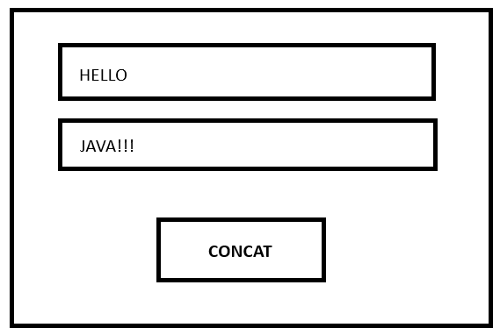 | Fig: After Clicking Button  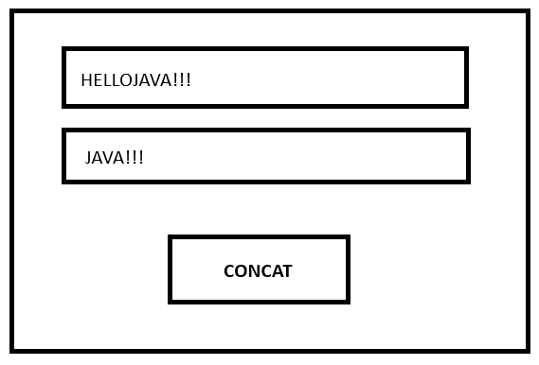

Q2. Write a Java program that implements the following system: [10 Marks]
- Interface Playable – Method void play(String instrument)
- Abstract Class MusicSchool that uses Playable
- Attributes: String name, double fee
- Constructor: accepts both parameters
- Implement the play(String instrument) method in the following way:
  - If the instrument is "Guitar" or "Piano" or "Violin", print a message saying that the instrument is being played.
  - Otherwise, throw a user-defined exception named InvalidInstrumentException with the message: "Instrument not taught here".
- Declare an abstract method void perform(String instrument).
- Class MusicAcademy which extends MusicSchool
- Override the perform(String instrument) method to print a message stating that the given instrument performance is taking place.
- Class MusicProgram (contains the main method)
- Create an object of MusicAcademy.
- Call the play() and perform() methods with valid and invalid instruments.
- Handle the thrown exception for invalid instruments and print the exception message.

